**Name: Oscar Ynoa**

**Student Id: 00308560**

**Course: Linux Administration (CIS-245-O1A)**

**Subject: The grep Family**

**Professor: Adrianna Holden-Gouveia**

**Due Date: 09/26/2021**

**Please include the command, a screenshot showing it works as intended, cite all sources you used, and give a short explanation of how the command works and why.**

**Important info: While doing this assignment it is important to move to the directory that has the datebook file and type correctly the name of everything. For example, if the file name is called datebook and you type Datebook is another different file. It’s not going to work.**

1. **Print all lines containing the string Street.**

**The command is “grep Street datebook’’**

**Explanation:** **Grep + word + filename. Grep will search for the given string the filename.** **In this case, grep will search for the pattern “Street” in the file named datebook**

1. **Print all lines where the person's first name starts with M. The command is** **“grep ^M datebook”**

**Explanation:** **^ indicates to search for the word at the beginning of the file.**

**In this case the function ^M will get the lines that begin with the letter M.**

1. **Print all lines ending in 000.** **The command is grep '000$' datebook**

**Explanation: $ indicates to search for the word or number at the end of the file. In this case indicating looking for 000 at the end of the line.**

1. **Print all lines that don't contain 408.**  **The command is “grep -v 408 datebook”**

**Explanation:** **-v means to avoid and print lines that do not contain the given word or number.**

1. **Print all lines where birthdays are in the year 1923.**

**The command is grep -E '[0-9]+/[0-9]+/23' datebook.**

**Explanation: grep -E: It is to tell grep that we are going to use metacharacters.**

**What are metacharacters? They are characters that has special meaning to a computer program.**

**‘‘: We start writing the formula inside an apostrophe. Everything inside will be combined**.

**[0-9]: We are telling grep to search for numerical characters from 0 to 9.**

**+: means followed by.**

**/23: We are telling grep to search in that year.**

1. **Print all lines where the phone number is in an area code that starts with an 8**

**The command is “grep -E ':8[0-9]{2}-[0-9]{3}-[0-9]{4}:' datebook”**

**Explanation: This option shows the number followed by 2 random numbers followed by a – to show an area code.**

**We need the command Grep -E to tell grep that we are going to use metacharacters.**

Explanation used above

**Dash -:** We use the dash for field separators and because that is how the phone number format is typed 835-365-1284.

In the case of **8[0-9]{2}** We are telling grep to grab the first number that is **8** followed by 2 random numbers. The {2} represents the digit. [**0-9]{3}:** We are telling grep to search for numerical characters as I explained above. The {3} represents the digit. Overall, we are telling grep to search for numerical character that contains 3 digits numbers**. [0-9]{4}** same theory, we are telling grep to search for numerical characters that has 4 digits.

**The grep filter searches a file for a particular pattern of characters and displays all lines that contain that pattern.**

1. **Print all lines containing an uppercase letter, followed by 5 lowercase letters, a comma, and one uppercase letter. The command is grep '[A-Z][a-z]\{5\}, [A-Z]' datebook**

**[A-Z**]: Used to search from the abecedary but in uppercase

**[a-z]** The same as above but in lowercase.

**Explanation:** We want an upper-case letter at first, so we write ‘**[A-Z],** followed by five lowercase letters, so we write **[a-z]** **\ that has** **{5\}**. The five represent the number of characters. The back slash represents “that must have” and we must close the formula by adding another back slash at the end of the digit five. Then by following the same basics we could say that the rest of this problem is almost solved. We write a comma, and another upper-case alphabetical bracket **[A-Z]** to get the last uppercase letter.

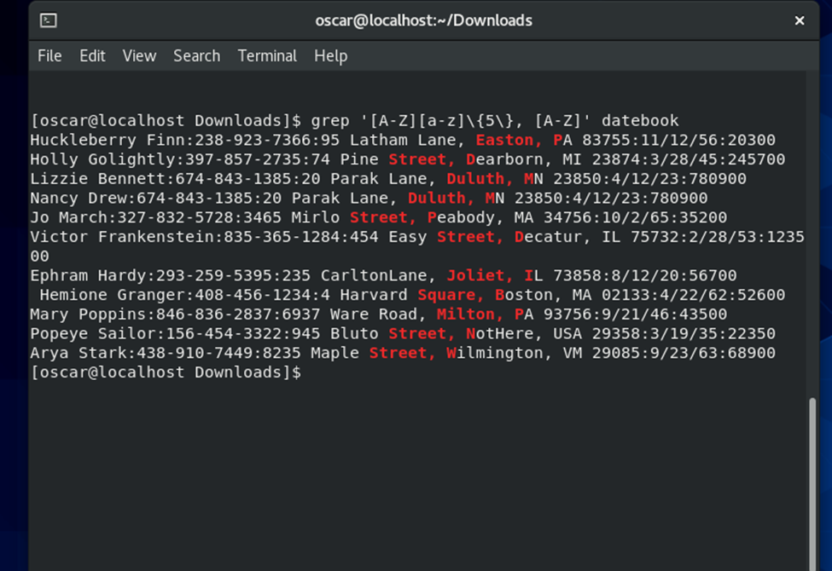

1. **Print lines where the address begins with a two- or three-digit number (so this would be 12 main st or 123 main street but not 1234 main street).**

**The command is grep -E ':([0-9]{2}|[0-9]{3}) [A-Z]' datebook**

**Explanation:** Because of the parenthesis this works together saying that grep looks for the first 2 or 3 digits followed by the first letter of the respective street. **[0-9]** gives me the first digit, followed by the extra numbers **{2}** represents the digit**.** The same with the [0-9] gives the first digit followed by **{3}** that represents the digit.So any number from [0-9] 2 times or any number [0-9] 3 times proceeded by a capital letter/**.** Texto

1. **Print lines preceded by a line number where the person is from Massachusetts (or MA) The command is grep -n -e "Massachusetts" -e "MA" datebook**

**Explanation: The -n Precedes each line by its relative line number in the file.**

The **-e** is used to expand the search patter of grep. That means that now grep can handle multiple patterns.

**Massachusetts** or **MA** is what we are telling grep to look for.

1. **Print lines containing an address that doesn't include Street or St**

**The command is grep -v -E '(Street|St)' datebook**

**Explanation:** The combination of this patterns **-v + -E** allowing to avoid and expand the grep searching system to look for anybody who does not live on a Street or ST.

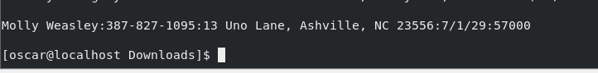

**Sources**

[https://flylib.com/books/en/4.356.1.25/1/](%20https://flylib.com/books/en/4.356.1.25/1/).

[**grep: https://youtu.be/Iif-DjWYoWY**](grep:%20https://youtu.be/Iif-DjWYoWY)

<https://www.cyberciti.biz/faq/howto-use-grep-command-in-linux-unix/>

<https://phoenixnap.com/kb/grep-command-linux-unix-examples>

<https://www.geeksforgeeks.org/grep-command-in-unixlinux/>

<https://swcarpentry.github.io/shell-novice/07-find/index.html>